Good Life Guy’s Kendall-Jackson Virtual Tasting – August 15, 2020
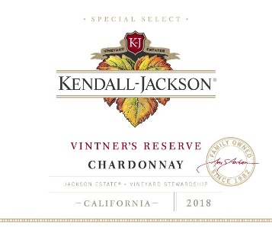
2018 Kendall-Jackson Vintner’s Reserve Chardonnay
Beautifully integrated tropical flavors such as pineapple, mango and papaya, with citrus notes that explode in your mouth. These flavors delicately intertwine with aromas of vanilla and honey to create depth and balance throughout. A hint of toasted oak and butter rounds out the long, lingering finish. ABV13.5%
NOTES:

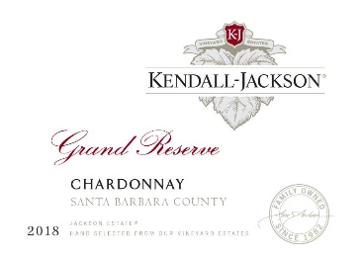
2018 Kendall-Jackson Grand Reserve Chardonnay
Lush tropical fruit intertwines with nice minerality from the calciferous soils in the Santa Maria and Los Alamos Valleys. There is a touch of floral notes from the small amounts of Dijon and Rued clones, and a hint of vanilla and spice to round out the rich, long finish. ABV14.5%
NOTES:

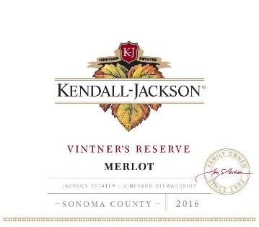
2016 Kendall-Jackson Vintner’s Reserve Merlot
Intricate layers of black cherry, plum, currant, and wild berry mingle with a hint of spice. The soft, delicate, elegant tannins of this Bordeaux varietal carry these aromas and flavors to a long lingering finish. ABV14.5%
NOTES:

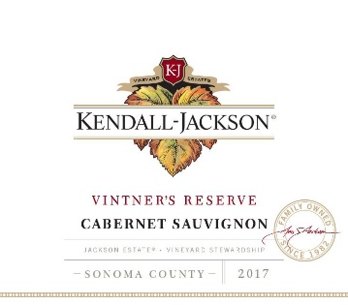
2017 Kendall-Jackson Vintner’s Reserve Cabernet Sauvignon
Aromas of lush, bright black cherry, blackberry and cassis draw you in. Round, rich, seamless tannins provide a robust backbone and supple mid-palate. Notes of cedar, vanilla and a hint of mocha linger on the finish. ABV13.5%
NOTES:


www.goodlifeguy.com – KNSS98.7/1330 – Saturday’s Noon-1:00 p.m. Central

