**Good Life Guy’s Rose Virtual Tasting Guide – July 3, 2021  
Saturday 6:00 p.m. Central Facebook LIVE**

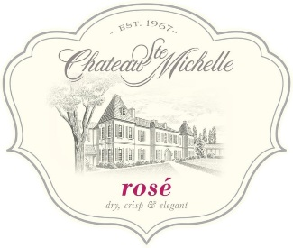

**2019 Chateau Ste Michelle Rosé, Columbia Valley Washington**48% Syrah, 35% Merlot, 17% Cabernet Sauvignon cold fermented in stainless. This Columbia Valley Rosé is a dry and elegant style wine with beautiful pale pink color hues. The fresh and lively wine offers bright aromas of watermelon and raspberry with flavors of wild strawberry, citrus zest and hints of melon. WE90 ABV12.5%



**2019 Marqués de Cáceres Rosé, Rioja Spain**96% Tempranillo, 4% Garnacha Tinta fermented separately in stainless. Pretty, luminous pale coral pink color. Floral bouquet of small red berry fruits and a slight touch of aniseed. Luscious flavors on tasting with refreshing acidity and balanced structure. An elegant rosé with character and good length.   
JS91 ABV14.5%

**2020 A to Z Wineworks Rosé, Newburg Oregon**Primarily Sangiovese, cold fermented in stainless. eautiful pale blush color, This Rosé greets with strawberry and watermelon aromas overlaid with light floral accents of rose hip tea, orange blossoms and white flowers followed by notes of honeydew, cantaloupe, nectarine, pear, persimmon, quince and zesty citrus. The palate follows suit with enticing flavors that hint of strawberries and cream, lemon curd, raspberry coulis and peach chutney. A perceptible minerality and restrained but juicy acidity lend backbone to present a supple, balanced structure.   
WE90 ABV13%

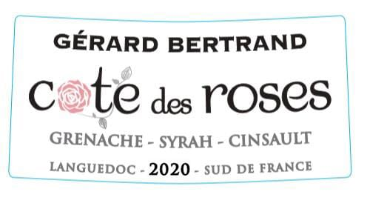**2020 Gerard Bertrand Cote des Roses, Languedoc Southern France**  
Grenache, Cinsault, Syrah. This Rosé is a soft, pale, brilliant pink with bluish tints developing over time towards more orangey nuances. The bouquet releases aromas of summer fruits, cassis, and redcurrant. Floral notes of rose along with hints of grapefruit complete the picture. The finish is fresh, offering notes of candy. On the palate, the impression is fresh and full, with great aromatic persistence and balance.   
WS90 ABV13%



[www.goodlifeguy.com](http://www.goodlifeguy.com) – KNSS 98.7/1330 – Saturday’s Noon-1:00 p.m. Central