**Good Life Guy’s Virtual Tasting Guide – The Chilean Wines of Viña Tinajas**

**Tinajas del Maule Winery was founded in 1997**, when the Mena Undurraga family acquired old, established vineyards in the town of Villa Alegre in the Maule Valley. They decided to upgrade the existing vineyards, which dated back to 1918, to take advantage of the region’s great potential. All this took place while maintaining the adobe buildings and oak casks, integrating the benefits of stainless steel and state-of-the-art equipment for vinification and bottling. Today the winery has a 3-million-liter (approx. 800,000 gal.) capacity and 300 hectares (741 acres) planted with six types of premium varietal grapes: Cabernet Sauvignon, Merlot, Pinot Noir, Carmenere, Sauvignon Blanc and Chardonnay.

**D.O Maule Valley**The Maule Valley, located 260 km (161 miles) south of Santiago, capital of Chile, is a grape- growing, wine-producing region that dates back to Spanish Colonial times. Today it has around 25,700 hectares (63,506 acres) of cultivated vines, divided into  9,000 hectares (22,239 acres) of white grapes and 16,000 (39,536 acres) of red. There are different sub-zones within the Maule Valley. All our wines come from our own grapes harvested from our estate vineyard, “Fundo Lagares del Maule”, located in Villa Alegre, which is a colder area near the Andes Mountains, where the significant temperature differential between day and night allows us to develop wines with deep color and intense aromas.

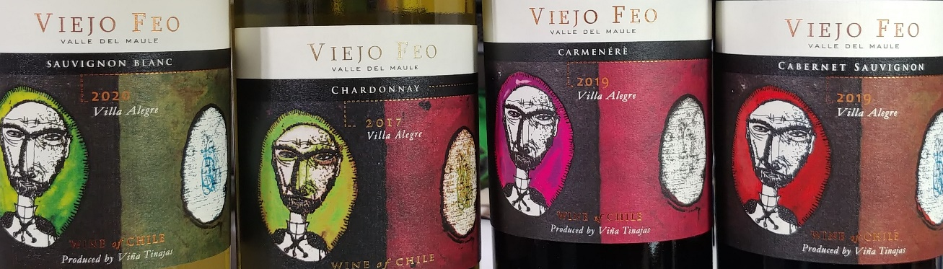  
**Your Wine Tasting NOTES:**

* 2020 Viejo Feo Sauvignon Blanc
* 2017 Viejo Feo Chardonnay
* 2019 Viejo Feo Carmenere
* 2019 Viejo Feo Cabernet Sauvignon



[www.goodlifeguy.com](http://www.goodlifeguy.com) – KNSS98.7/1330 – Saturday’s Noon-1:00 p.m. Central

