Virtual Tasting with Good Life Guy – The Wines of Duckhorn Decoy – February 6th, 2021
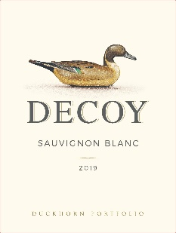
2019 Decoy Sonoma County Sauvignon Blanc
100% Sauvignon Blanc, 100% stainless steel Whole cluster pressed and fermented cold in stainless steel tanks to preserve delicate aromatics. From its exotic aromas of guava, Meyer lemon and passionfruit to its crisp acidity and citrus and stone fruit notes, this delicious Sauvignon Blanc dazzles with bright, fresh flavors. On the palate, alluring layers of tangerine, lemon peel, white peach and honeysuckle add nuance to a long, zesty finish. ABV13.5%
NOTES:

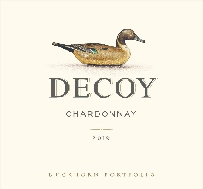
2019 Decoy Sonoma County Chardonnay
100% Chardonnay Fermented and aged in 30% new French oak Aged on lees for 8 months with stirring to increase texture and weight, 20% underwent Malolactic fermentation. This tantalizing Chardonnay offers vibrant aromas of Fuji apple, ripe pear and lemon zest. The juicy orchard fruit and citrus flavors continue on the palate, where refreshing acidity and hints of caramelized French oak add nuance and richness to a bright, lingering finish. ABV13.5%
NOTES:

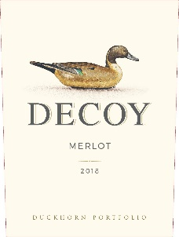
2018 Decoy Sonoma County Merlot
Subappellations; 54% Dry Creek, 16% Alexander Valley, 10% Russian River, 5% Knights Valley. 98% Merlot, 1% Cabernet Sauvignon, 1% Petit Verdot Aged 12 months in 100% French oak, 40% new. This lush and inviting Merlot displays layers of black cherry, blueberry and plum underscored by dark chocolate, cedar and mineral notes. On the palate, balanced acidity adds poise and elegance, while silky tannins carry the wine to a fruitful and concentrated finish. ABNV13.9%
NOTES:

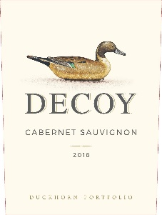
2018 Decoy California Cabernet Sauvignon
Subappellations ; 66% Sonoma County, 24% Central Coast, 6% North Coast, 4% California. 78% Cabernet Sauvignon, 13% Merlot, 4% Zinfandel, 2% Petite Sirah, 2% Syrah, 1% Petit Verdot aged in 100% French oak. Displaying the lushness and balance that define great Cabernet Sauvignon, this inviting wine features layers of blackberry, black cherry and blueberry, along with notes of dark chocolate and fresh spearmint. On the palate, the bright, juicy fruit flavors are framed by rich, refined tannins that carry the wine to a long, satisfying finish. ABV13.0%
NOTES:

www.goodlifeguy.com – KNSS98.7/1330 – Saturday’s Noon-1:00 p.m. Central

