**19 Crimes Tasting Guide – February 27, 2021 with Good Life Guy**

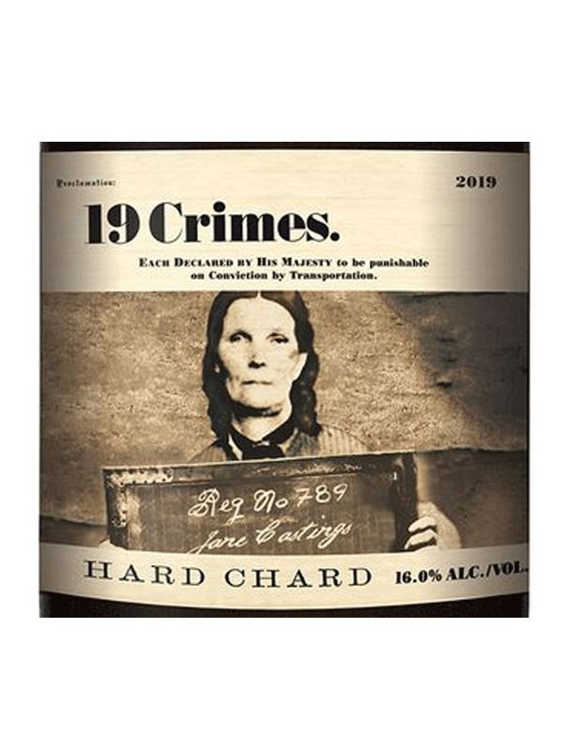**2019 19 Crimes Hard Chard**Bold and strong in character, this deep rich and golden Chardonnay is filled with stone fruit aromas and a sweet textured palate. The criminally intense toasty oak notes have hints of butterscotch and honey balanced with layers of ripe fruit. This full bodied, powerful wine finishes with rich notes of butter and vanilla. ABV16%  
NOTES:

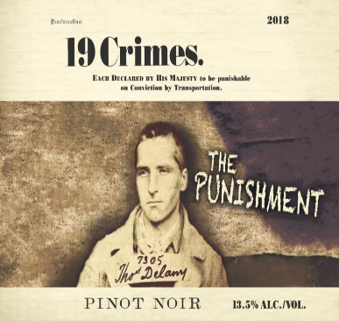  
**2018 19 Crimes Pinot Noir**Medium intense burgundy color with a youthful purple rim. Notes of cherry and strawberry fruit complement rich vanillin overtones giving warm and inviting aromas on the nose of this wine. The palate is medium-bodied with soft, round tannins, cherry and strawberry fruit with sweetness which complements the vanilla and spice oak undertones. All these elements combined create a well-balanced, enjoyable wine with a long finish. ABV14.1%  
NOTES:

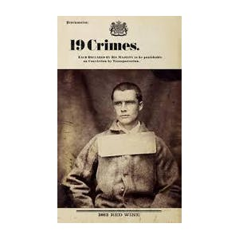

**2018 19 Crimes Red Wine**Dark purple color, polished, expressive and distinctive, with a green olive note weaving through the ripe blueberry and spice flavors, lingering easily on the deftly balanced and medium-weight finish. Shiraz, Pinot Noir, Grenache, and Cabernet. ABV13.5%  
NOTES:

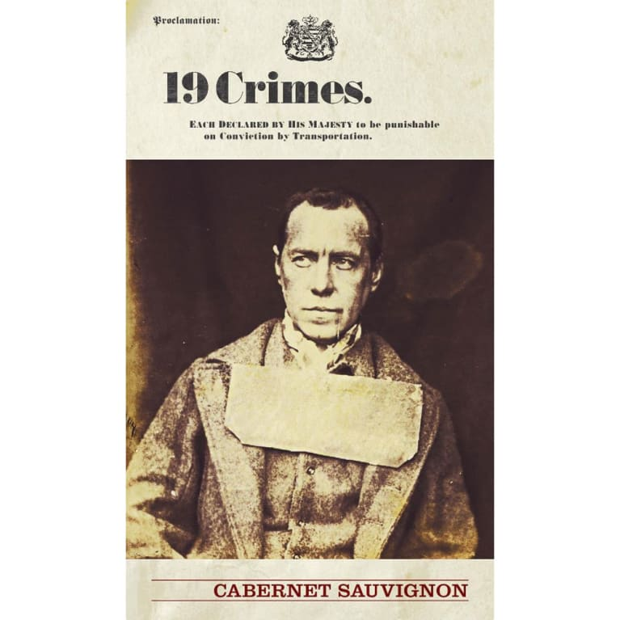**2018 19 Crimes Cabernet Sauvignon**A rich bright red to crimson color, this wine has an intense nose with lifted vanilla aromatics balanced with red currants, violets, and mulberry fruits. It is a wine that is firm and full on the palate with a subtle sweetness giving a rich mouth feel. The vanilla aromatics carry through on the palate and compliment subtle flavours of red currants, dark cherries, and chocolate. The palate is filled with dark berry fruit and the soft tannins provide a lingering finish. ABV13.5%  
NOTES:

[www.goodlifeguy.com](http://www.goodlifeguy.com) – KNSS98.7/1330 – Saturday’s Noon-1:00 p.m. Central