**Sean Minor Tasting Guide – Virtual Tasting with Good Life Guy – January 9, 2021**

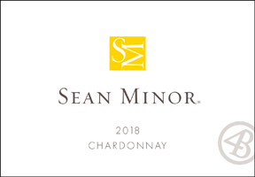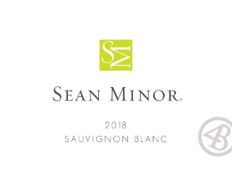**2018 Sean Minor California Sauvignon Blanc**This Sauvignon Blanc is a golden straw color and displays aromas of lime, orange blossom, melon, grass and a touch of tropical fruit notes. On the entry, the juicy grapefruit acidity integrates well with a medium body mid palate mouth feel. The kiwi, green apple and peach flavors evolve into a hint of minerality that adds complexity to the finish. ABV13% SFIWC Double Gold  
NOTES:  
  
  
**2018 Sean Minor Central Coast Chardonnay**The Central Coast Chardonnay is a light golden straw hue and displays aromas of pear, apple, tropical citrus and pineapple with subtle notes of vanilla. On the entry, crisp vibrant flavors of guava, pear and green apple integrate well with a touch of minerality and a medium body mouth feel. These flavors linger to provide a full and lengthy finish. ABV13.5% WE90  
NOTES:

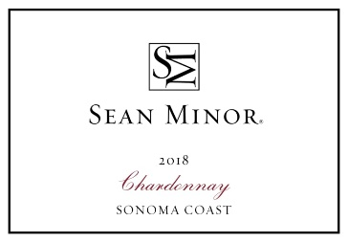

**2018 Sean Minor Sonoma Coast Chardonnay**Sonoma Coast Chardonnay is a light golden straw hue and displays aromas of apple blossom, yellow peach, nectarine and oak spice with hints of vanilla and butterscotch. On the entry, crisp vibrant flavors of ripe pear and peach with a touch of minerality and a medium body mouth feel which evolves into a full, lengthy and satisfying finish. ABV13.5% WS90  
NOTES:

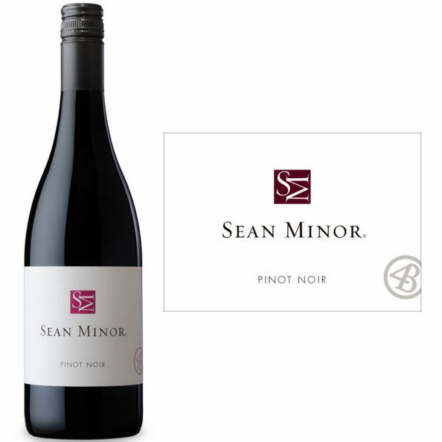

**2018 Sean Minor California Pinot Noir**California Pinot Noir is a medium bodied wine which displays aromas of floral components, red fruit and dark cherries. On the palate, the Pinot offers luscious flavors of dark cherry, strawberry and violets, combined with subtle layers of spice. The integrated bright acidity and sweet oak nuances provide a lingering finish. ABV13.5% SDIWC92  
NOTES:

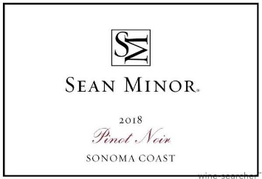

**2018 Sean Minor Sonoma Coast Pinot Noir**This Sonoma Coast Pinot Noir is medium-bodied with cherry, strawberry and plum nuances; surrounded by light toast flavors. On entry, the wine displays bright cherry and berry flavors with earthy and sweet oak notes throughout the mid-palate. The spicy finish lingers on the palate framed by fresh fruit and silky round tannins. ABNV13.5% WS90  
NOTES:



[www.goodlifeguy.com](http://www.goodlifeguy.com) – KNSS98.7/1330 – Saturday’s Noon-1:00 p.m. Central