**Great Wine for Christmas Dinner Virtual Tasting with Good Life Guy – December 19, 2020**

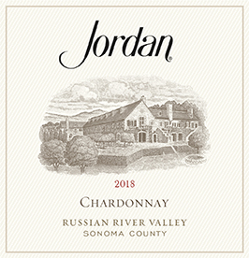**2018 Jordan Russian River Valley Chardonnay**A vintage defined by its crispness, vibrancy and freshness. Pretty aromas of honeysuckle, lemon blossom and Fuji apple spring from the glass. The palate boasts bright, lively layers of citrus with a hint of oak and creaminess from careful barrel aging and bâtonnage. Flavors of kumquat, lemon and Fuji apple linger in the juicy, mouthwatering finish. Enjoy now or cellar through 2023. ABV13.7% WW93  
NOTES:

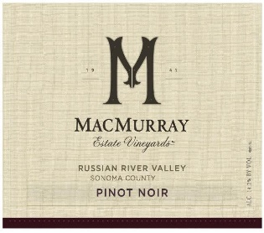

**2017 MacMurray Estate Vineyard Russian River Pinot Noir**MacMurray Estate Vineyards Russian River Valley Pinot Noir opens with aromas of dark berries and violets. On the plush, silky palate, delicate cherry and plum characteristics meld with lavender, rose petal and subtle hints of earth. Notes of oak and vanilla feature on the lingering finish in this vibrant Pinot Noir. ABV14.5% WS92  
NOTES:

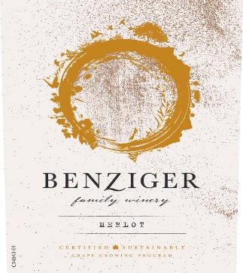

**2017 Benziger Family Winery Sonoma County Merlot**This 2017 Sonoma County Merlot has inviting aromas of dark fruit and spice which translate well at first sip. Flavors of black cherry, ripe plum, and a dusting of dark chocolate carry through the palate. Velvety tannins come from behind to give this merlot a smooth, polished finish. ABV14.5% TP91   
NOTES:

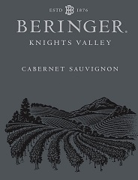

**2017 Beringer Knights Valley Cabernet Sauvignon**This Cabernet is set each vintage as a Bordeaux blend, with soft and silky tannins and a plush, full mouth-feel setting it up for immediate enjoyment, although it's built to age and develop further complexity. Aromas of dried herbs, cedar, clove and lavender join flavors of dark red fruit led by figs, black cherry, currants, boysenberry, huckleberry, raspberry, and evident oak spice are joined with more traditional Knights Valley tones of black olive, wild sage and mocha chocolate. Fine acidity and balance with an elegant structure lead to a lingering, memorable finish. ABV14.8% JS91  
NOTES:



[www.goodlifeguy.com](http://www.goodlifeguy.com) – KNSS98.7/1330 – Saturday’s Noon-1:00 p.m. Central