**Tasting Notes - Merlot with Good Life Guy**

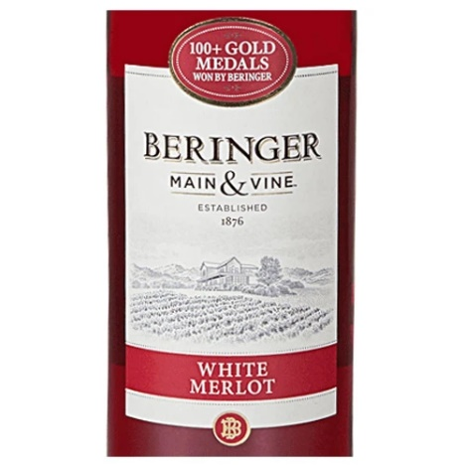**NV Beringer Main & Vine White Merlot, California**To achieve the perfect color in their White Merlot, Beringer's winemaking team gently destems and presses the Merlot grapes, leaving the red skins in contact with the juice for approximately three hours. As soon as the desired soft, red-purple hue is achieved, the juice is removed. Slow, cool fermentations follow to retain the bright acidity, fresh melon and citrus flavors. The resulting wine is a vibrant blend of fresh berry and zesty orange peel flavors, with a hint of nutmeg spice. ABV11.5%  
NOTES:

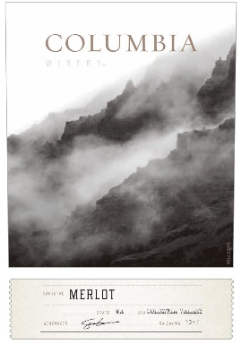**2017 Columbia Winery Merlot, Columbia Valley Washington**83% Merlot, 9% Syrah, 8% Malbec warm stainless fermentation followed by partial oak treatment. This rich, full-bodied Columbia Valley Merlot opens with hallmark dark purple color and enticing aromas of plum, clove and baking spice. On the fruit-forward palate, dark fruit flavors of black cherry, wild blackberry and juicy plum are met with pronounced notes of sweet oak, vanilla and hints of mocha for a silky, textured mouthfeel. Notes of ripe raspberry and caramel linger on the generous finish. ABV13.9  
NOTES:

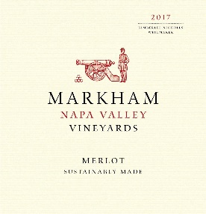**2017 Markham Vineyards Merlot, Napa Valley California**87% Merlot, 9% Cabernet Sauvignon, 3% Petite Sirah, 1% Malbec fermented in stainless then aged 15.5 months in American oak, 32% new. Displaying a lovely balance of candied cherry laced with dark chocolate aromas. Floral fruit runs from strawberry preserves to boysenberry and is accented with an assortment of baking spices. The velvety entry melts like chocolate on the palate providing a silky but dense mouthfeel with a long, intense finish. ABV14.6%  
NOTES:

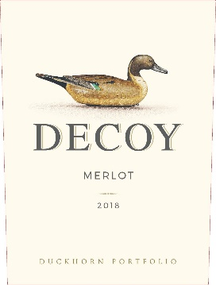

**2018 Duckhorn Decoy Merlot, Sonoma County California**98% Merlot, 1% Cabernet Sauvignon, 1% Petit Verdot aged 12 months in 100% French oak, 40% new. This lush and inviting Merlot displays layers of black cherry, blueberry and plum underscored by dark chocolate, cedar and mineral notes. On the palate, balanced acidity adds poise and elegance, while silky tannins carry the wine to a fruitful and concentrated finish. ABV13.9%  
NOTES:



[www.goodlifeguy.com](http://www.goodlifeguy.com) – KNSS98.7/1330 – Saturday’s Noon-1:00 p.m. Central