**Great Value Bubbles for the Holidays or any Days!  
December 5, 2020 – Facebook/goodlifeguy LIVE 6:00 p.m. Central**

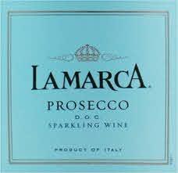**NV Lamarca Prosecco – Italy, Veneto Region-Prosecco DOC**Prosecco is a bright and versatile Sparkling Wine named for the Italian region from which it comes. Produced from 100% white Glera grape, with a delicate, golden straw color and sparkling with lively effervescence, the La Marca Prosecco taste offers hints of ripe lemon, green apple and grapefruit framed by mineral undertones. The palate is fresh and clean, with aromas of fresh citrus, honeysuckle and white flowers. ABV11%  
NOTES:

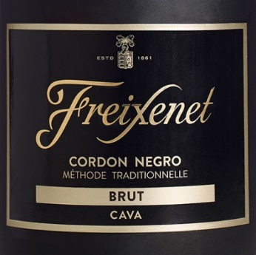**NV Freixenet Cordon Negro Brut Cava – Spain, Catalonia-Penedès** A blend of 35% Macabeo, 25% Xarel·lo, 40% Parellada this Cava displays an exceptional, fresh, fruity style and a lingering aroma. Notes of apple, pear, citrus, and a touch of ginger. As the #1 imported sparkling wine in the world, crisp and creamy Cordon Negro Brut’s delicate bubbles make this the ideal wine for any occasion. Pairs well with popcorn and movie nights. ABV11.5%  
NOTES:

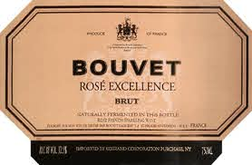**NV Bouvet Ladubay** **Rosé Excellence Brut – France, Loire Valley**100% Cabernet Franc from more than 100 plots in the Loire Valley. Grape pressing is monitored in the vineyards; color is obtained with a quick maceration of the red Cabernet Franc on its skins. Fermentation takes place in stainless steel, then the wines are blended and the cuvée is bottled for the second fermentation, following the traditional method. Bright salmon pink in color with fine bubbles and a pleasant mousse. Fresh raspberry, red currant and peach on the nose is given structure on the palate with black currant and quince, earthy notes and fine herbal piquancy. ABV12.5%  
NOTES:

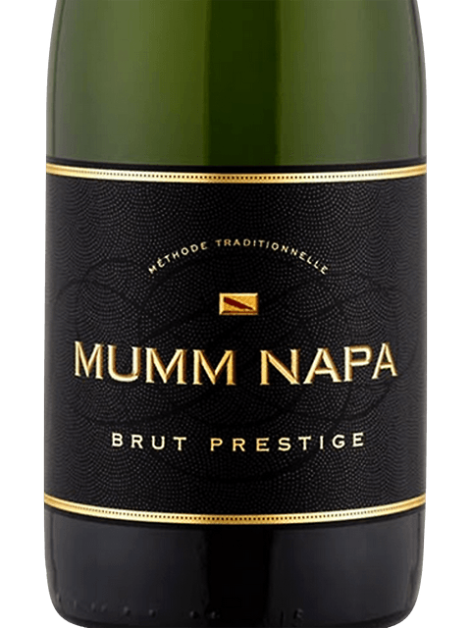**NV Mumm Napa Brut Prestige – California, Napa Valley**45% Chardonnay, 45% Pinot Noir, 10% Pinot Gris & Pinot Meunier from select Napa Vineyards fermented in stainless. A few select lots are aged in French oak barrels to add depth, complexity, and spiciness. The finished blend is bottled for second fermentation, with an average of 18 months’ yeast ageing to add complexity, subtle dough flavors, and layers of creaminess. Featuring bright citrus, red apple, stone fruit and creamy vanilla aromas, with hints of toast, honey and gingerbread spice. Its vibrant flavors are balanced by fine acidity and a rich, lingering finish. ABV12.5%  
NOTES:



[www.goodlifeguy.com](http://www.goodlifeguy.com) – KNSS98.7/1330 – Saturday’s Noon-1:00 p.m. Central