**Good Life Guy’s Round Pond Virtual Tasting Guide**

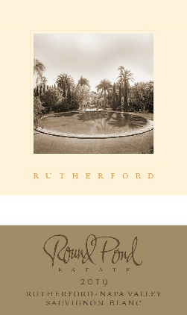**2019 Round Pond Rutherford Sauvignon Blanc**This wine is focused on purity of fruit; it is a flip book of the varietal as it ripens on our Rutherford estate. We capture different snapshots of the grape’s character by making three picking passes during harvest. This provides the wine with multiple layers of fruit.   
100% Sauvignon Blanc.  
NOTES:

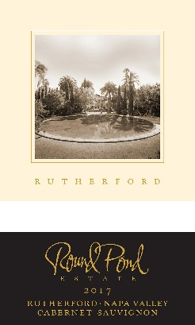

**2017 Round Pond Rutherford Cabernet Sauvignon**A true reflection of that signature Rutherford dust, this Cabernet Sauvignon embodies an old world meets new world style. Hand crafted entirely from our Rutherford Estate and sourced from the top 5% off the property, this wine exhibits rich characteristics of dark complex fruits, minerality and balanced intensity.   
77% Cabernet Sauvignon, 12% Petit Verdot, 7% Malbec, 4% Merlot  
NOTES:

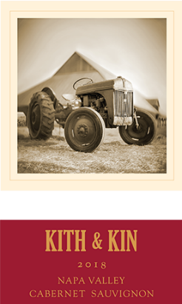

**2018 Kith & Kin Napa Valley Cabernet Sauvignon**“Kith & Kin” is sourced from all corners of the Napa Valley but has its heart rooted in Rutherford. Focused on a red fruit-forward style, this balanced wine shows warm herbs and spices with plush velvety tannins. Not only does this come across like a much more expensive Napa Valley Cab, but it is exceedingly approachable – especially for its youth. A splash of juicy black raspberry and plum engage with dark chocolate tannins – and with a slight grainy quality, a textural delight. High-toned acidity puts a light on savory notes of briar, sandalwood and black tea.  
84% Cabernet Sauvignon, 10% Petit Verdot, 5% Merlot, 1% Malbec.  
NOTES:



[www.goodlifeguy.com](http://www.goodlifeguy.com) – KNSS98.7/1330 – Saturday’s Noon-1:00 p.m. Central