**Good Life Guy’s Virtual Wine Tasting – Autumn & Art 2020**

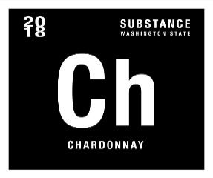**2018 Wines of Substance “Ch” Columbia Valley Chardonnay**100% barrel fermented Chardonnay from Frenchman Hills Vineyard brought up in 15% new oak, the This Chardonnay offers plenty of orchard fruits, honeyed flowers, and brioche notes as well as a medium-bodied, round, beautifully textured style on the palate. Great value from Charles Smith. ABV13.5%  
NOTES:

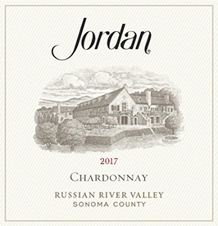

**2017 Jordan Vineyards Russian River Chardonnay**A nice balance of delicacy and deliciousness. Inviting aromas of honeysuckle and lemon peel lead to bright flavors of stone fruits and citrus. The palate is elegant yet succulent, with layers of oak-laced lemon, pears, quince and white peach—all supported by uplifting acidity. Its crisp, citrusy finish lingers on the palate, enticing you to take another sip. ABV13.6%  
NOTES:

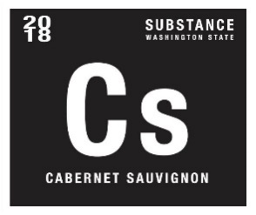**2018 Wines of Substance “Cs” Columbia Valley Cabernet**Cabernet Sauvignon Cs, shows wonderful dark-fruit and olive character of a ripe cabernet sauvignon, but the polished tannins fold over the wine. It’s full-bodied, yet agile and focused at the finish. Classy cassis fruits, lead pencil, and tobacco notes all emerge from the glass, and it’s medium to full-bodied, with ripe tannin, integrated oak, and a great finish. ABV14%  
NOTES:

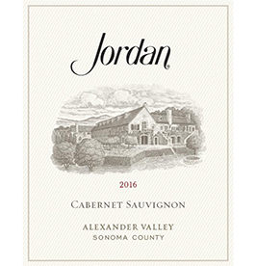

**2016 Jordan Vineyards Alexander Valley Cabernet**Aromas of black cherries wrapped in a spice box of nutmeg, clove and allspice jump from the glass. The palate is filled with flavors of black currants and plum that lead seamlessly to silky tannins and black cherry notes. Blackberry, Mission fig and black cherry notes linger on the finish. ABV13.8%  
NOTES:



[www.goodlifeguy.com](http://www.goodlifeguy.com) – KNSS98.7/1330 – Saturday’s Noon-1:00 p.m. Central