**Chateau St. Jean Tasting Guide – Good Life Guy’s September 5, 2020**

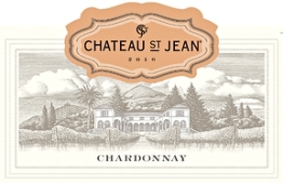 **2017 Chateau St. Jean California Chardonnay**This classic Chardonnay displays bright aromas of lemon cream, mango and notes of toasted hazelnut. Soft mouthfeel with balanced oak structure complimenting the fruit. This wine has a subtle elegance with a lingering finish. ABV13.8%  
NOTES:

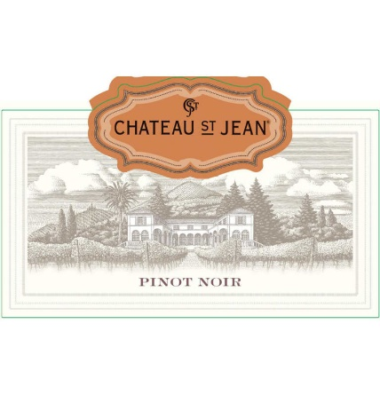

**2017 Chateau St. Jean California Pinot Noir**A classic Pinot Noir with bright aromas of cherry, ripe strawberry, and subtle baking spice. Inviting aromas lead to a smooth mouthfeel with flavors of juicy ripe fruit, vanilla & spice notes accented by hints of wood smoke. The wine is flavorful with a long pleasing finish. ABV13.8%  
NOTES:

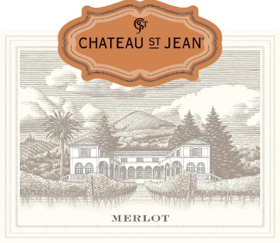 **2017 Chateau St. Jean California Merlot**Crafted in an approachable California style from coastal vineyards, this beautifully balanced wine offers up ripe fruit aromas of fresh berry, red plum, toasted oak and cherry leading to a palate filled with flavors of fresh berry pie, milk chocolate, and notes of black tea. Smooth tannins and a juicy mouthfeel. The focused core of cherry and plum linger on the long, complex finish. ABV13.8%  
NOTES:

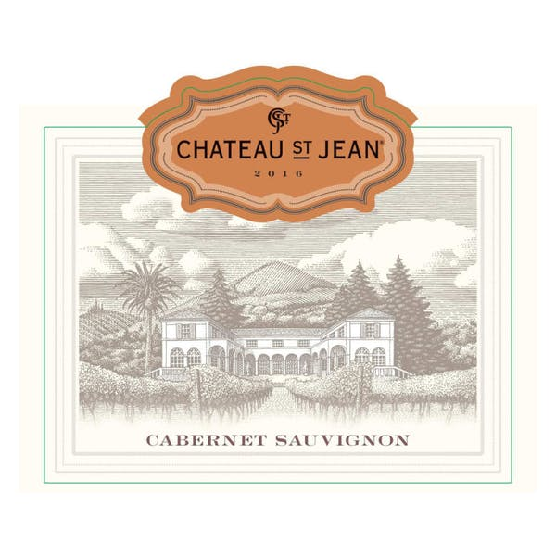

**2017 Chateau St. Jean California Cabernet Sauvignon**Scents of black plum and tobacco along with a suede texture and hints of toasty oak give this wine a darkly vinous feel. It’s lean but well-structured for a wine at this price. Dark fruit, herbs and spice with flavors firm and long, a bargain pour for steak. ABV13.8%  
NOTES:



[www.goodlifeguy.com](http://www.goodlifeguy.com) – KNSS98.7/1330 – Saturday’s Noon-1:00 p.m. Central