**Wines of Lodi Tasting Guide – Good Life Guy’s September 12, 2020**

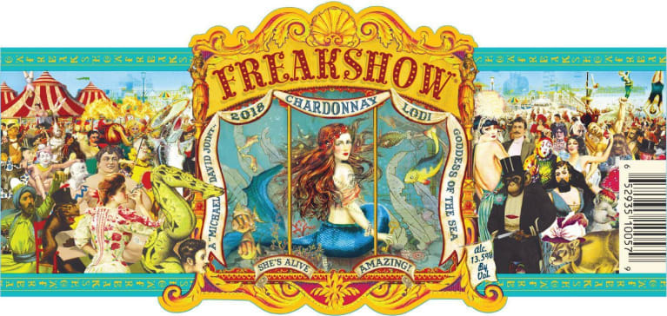**2018 Michael David “Freakshow” Lodi Chardonnay**Freakshow Chardonnay is fruit forward and crisp, with mouthwatering aromas of juicy mango, summer stone fruit, cinnamon spice and buttered popcorn. Enchanting flavors of nectarine, stewed Golden Delicious apples, butterscotch, hickory and a hint of vanilla and coconut on the finish. ABV13.5%  
NOTES:

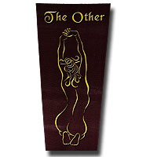

**2017 Peirano Estate “The Other”, Lodi Red Blend**60% Cabernet Sauvignon, 30% Merlot and 10% Syrah. vibrant color and aromas of maraschino cherries, cranberries, raspberries and a hint of fresh pomegranate. The palate explodes with a wave of big, juicy plums, blackberries and maraschino cherries, with a hint of dried cranberries and black pepper, leading to a long, totally seductive finish. ABV13.8%  
NOTES:

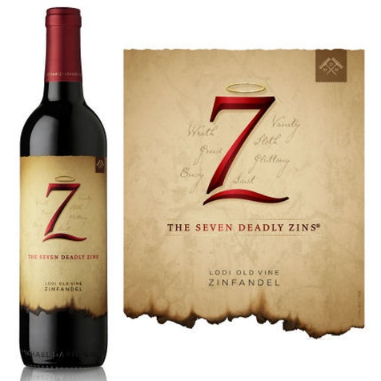**2016 The Seven Deadly Zins, Lodi Old Vine Zinfandel**Sinful indeed, our 2016 Old Vine Zinfandel is full-bodied and seductive. Heaps of jammy berry fruit are followed by aromas of leather, oak and spice notes. On the palate the wine is round and layered showing flavors of dark fruits, currants and toffee through a lingering spice-touched finish. ABV15%  
NOTES:

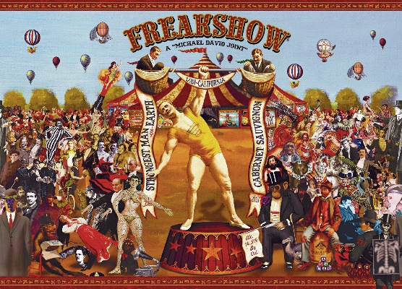**2017 Michael David “Freakshow” Lodi Cabernet**86% Cabernet and 14%Petite Sirah aged 13 months in oak. Freakshow Cabernet spotlights the power and ­finesse embraced by Michael David’s Strongman! This Cab is deep garnet in color with aromas of cranberry, dark chocolate, vanilla and exotic spice. He’s larger-than-life, medium in body, and boasts bold flavors of raspberry, cocoa nib and pepper that stand out from the oak and spice-laden fi­nish. ABV14.5%  
NOTES



[www.goodlifeguy.com](http://www.goodlifeguy.com) – KNSS 98.7/1330 – Saturday’s Noon-1:00 p.m. Central