**Good Life Guy’s Virtual Wine Tasting – Saturday August 22, 2020  
Face Book LIVE 6:00 p.m. Central - A Selection of Joel Gott Wines**

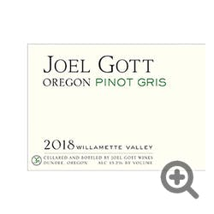**2018 Joel Gott Pinot Gris, Oregon**100% Pinot Gris stainless steel fermented with aromas of citrus, white peach and honeydew melon. The wine opens with bright acidity and citrus notes followed by complex fruit flavors on the mid-palate and a long, clean balanced finish. ABV13.2%  
NOTES:

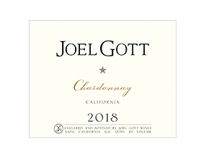**2018 Joel Gott Chardonnay, California**100% Chardonnay stainless steel fermented with a small portion aged in French oak. The nose offers aromas of ripe pear, peach, melon and honeysuckle with citrus notes. On the palate, the wine opens with bright fruit flavors and acidity, leading to a round mouthfeel on the mid-palate and crisp minerality on the finish. ABV13.9%  
NOTES:

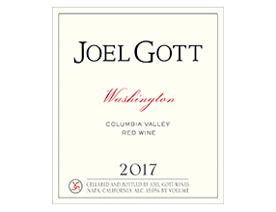

**2017 Joel Gott Washington Red Blend, California**Palisades red wine has aromas of red cherries, chocolate, leather, cherry compote, baking spices and notes of toasted oak. On the palate, bright red fruit flavors lead to smooth tannins and subtle acidity on the mid-palate with notes of vanilla on the long, delicate finish. ABV13.9%  
NOTES:

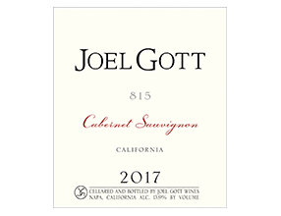**2017 Joel Gott 815 Cabernet Sauvignon, California**The 815 Cabernet Sauvignon is 100% Cab, aged in 25% new American oak. Look for aromas of bright red fruit, black cherry and raspberry with notes of vanilla and white pepper. The wine opens with dark, concentrated fruit flavors, followed by balanced tannins on the mid-palate, and notes of cedar on the long, textured finish. ABV13.9%  
NOTES:



[www.goodlifeguy.com](http://www.goodlifeguy.com) – KNSS98.7/1330 – Saturday’s Noon-1:00 p.m. Central