August 8, 2020 Virtual Wine Tasting. Good Life Guy says…
“…put on your Non-Vinifera tasting hat and let’s enjoy some fine Kansas Wine!”
Special guest is Jeff Sollo from Grace Hill
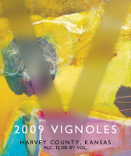
NV Grace Hill Vignoles.
Made from Grace Hill grown Vignoles grapes, this dry white wine is crisp and fruity. It is unoaked and full of citrus flavors that match very well with pasta or seafood. ABV 12.50%
NOTES:

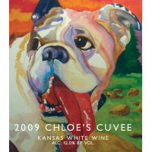
NV Cloe’s Cuvee
An off-dry white wine, this blend of estate grown Chardonel and Traminette grapes is made in a Riesling Style and has notes apple and pear that shine through its subtle sweetness. ABV 12.00%
NOTES:

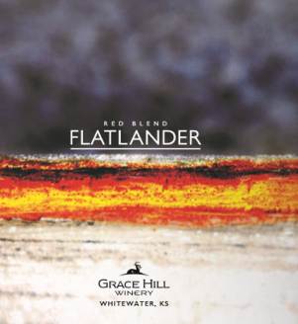
NV Grace Hill FlatLander Red Blend
A dry red blend with a luscious mouthfeel and bright red fruit, aromas of strawberry, cherry and pomegranate lead to a soft dry finish, it's the ideal weekday red! ABV 12.00%
NOTES:

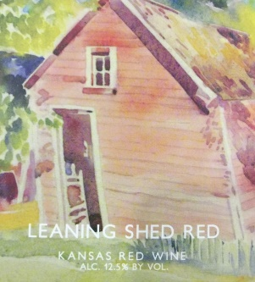
NV Grace Hill Leaning Shed Red
This dry red is our biggest bodied wine to date. This blend of Cabernet Franc, Crimson Cabernet, and Lemberger is bursting with ripe fruit flavors and complemented with a healthy amount of tannin, this wine is made to drink or can be sat down to age for a while. ABV 12.50%
NOTES:

www.goodlifeguy.com – KNSS98.7/1330 – Saturday’s Noon-1:00 p.m. Central

Non-vinifera grape description and information
Vignoles: A complex hybrid wine grape variety that was developed by J.F. Ravat originally named Ravat 51. According to Ravat, "Ravat 51" was the result of a cross made in 1930 using the complex hybrid wine grape Seibel 6905 (also known as Le Subereux) and a clone of Pinot Noir known as Pinot de corton. Can be vinified sweet to dry.
Chardonnel: Late ripening white wine hybrid grape which can produce a high quality wine with varietal character. It is a result of a cross made by the New York State Agricultural Experiment Station of the popular French American hybrid Seyval and the classic vitis vinifera Chardonnay.
Traminette: A cross of the French American hybrid Joannes Seyve 23.416 and the German Vitis vinifera cultivar Gewürztraminer made by Herb C. Barrett ca. 1965 at the University of Illinois, Urbana/Champaign. His intention was to produce a large clustered table grape with the flavor of Gewürztraminer.
Crimson Cabernet: The parentage combines the Bordeaux King of Grapes, Cabernet Sauvignon, and the State Grape of Missouri, Norton. The result is a disease resistant, cold hardy hybrid grape with genes that trace back to 18th century Chateau Mouton.
Cabernet Franc (vinifera): One of the major black grape varieties worldwide. It is principally grown for blending with Cabernet Sauvignon and Merlot in the Bordeaux style, but can also be vinified alone, as in the Loire's Chinon.
Lemberger: Also called Blaufränkisch, is a dark-skinned variety of grape used for red wine. Blaufränkisch, which is a late-ripening variety, produces red wines which are typically rich in tannin and may exhibit a pronounced spicy character.

Winery Overveiw:
Doctors David and Natalie Sollo, started Grace Hill a little over 13 years ago They say “making wine is nearly as pleasurable as consuming it.” The Sollo’s, both still active Doctors, live on the estate and their two sons Jeff and Brian are actively involved in the day to day operation of the winery. With over 25 acres of vineyards near the town of White Water, the entire family works the vineyard - trellising, pruning or spraying, while Natalie handles the extensive bookkeeping connected with producing an alcoholic beverage in Kansas. They employ a talented staff and have many volunteers that help with the complex aspects of the operation.

