**Good Life Guy’s Virtual Tasting Guide – The California Wines of Line 39**

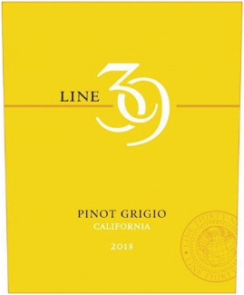**2018 Line 39 California Pinot Grigio**This wine is clean and refreshing, boasting modest but tasty peach and apple flavors on a fairly crisp texture. Displaying fresh, delicate floral aromas in the nose. In the mouth, there are citrus flavors of lemon and lime supported by a full, long finish. The wine is perfect for sipping al fresco on a warm afternoon. ABV13% WE87 Best Buy, Tastings Silver.  
NOTES:

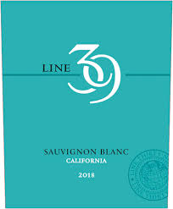

**2018 Line 39 California Sauvignon Blanc**This Sauvignon Blanc opens with vibrant aromas of grapefruit and lemon with subtle grassy characters and a crisp clean finish. This wine is a fine accompaniment to shellfish or on its own after a long day. ABV13.5% WE87, Gold-LA International Wine Competition  
NOTES:

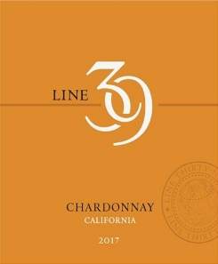 **2017 Line 39 California Chardonnay**This Chardonnay is a rich, medium-bodied wine with hints of oak and lush tropical and stone fruit flavors on the palate.  Crisp and refreshing, this wine can be enjoyed with a variety of fish and chicken dishes or all by itself on a warm summer afternoon. ABV14.5% Gold-TEXSOM International Wine Competition  
NOTES:

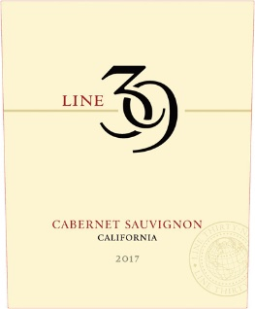

**2016 Line 39 California Cabernet Sauvignon**This Cabernet Sauvignon exhibits rich fruit flavors of currant, blackberry and ripe plum with hints of black tea on the palate. The wine finishes with subtle, smooth tannins that don’t overpower this easy-to-drink Cab. ABV13.5% 95-California State Fair  
NOTES:

The Good Life radio show on KNSS 98.7/1330 KNSS Noon-1:00 p.m. CDT **www.goodlifeguy.com**