**Good Life Guy’s Atlas Wine Company Tasting with winemaker Alexandre Remy, August 1, 2020**

**NV Oro Bello Blanc de Blancs 187ml can from 4-pack $18  
Tasting Notes**: Effervescent with elegant fruit aromas that range from pineapple to kiwi to meyer lemon.   
**AVA**: California. **Grapes**: 78% Chardonnay, 15% Sauvignon Blanc, 7% Muscat  
Floral, fruity aromas lead to tones of cherry and peach on the palate. The wine has generous mouthfilling bubbles, good acidity and a hint of sweetness that promotes a smooth texture. ABV12.3%  
NOTES:

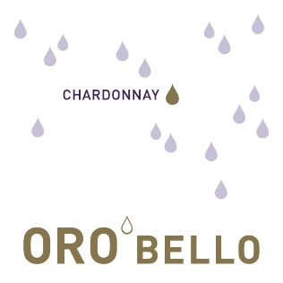**2018 Oro Bello Chardonnay $18.00  
Tasting Notes**: Elegant Fruit aromas range from pineapple to kiwi with Meyer lemons notes. Mouthfeel is smooth yet fresh and balanced with well-integrated toasted oak.  
**AVA**: 80% Lodi – 20% Sonoma Coast, California. **Grapes**: 100% Chardonnay  
This rich, buttery wine shows plenty of baked apple and vanilla aromas, adding malted milk and caramel notes on the palate. It’s full bodied & mouth filling in texture. ABV13%  
NOTES:

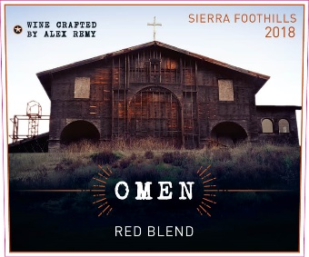**2018 Omen Red Blend $20.00  
Tasting Notes**: Blackberry Jam, Cherry, and dark chocolate aromas with spicy hints of licorice and clove.  
**AVA**: Sierra Foothills, California. **Grapes**: 63% Zinfandel, 21% Syrah, 8% Barbera, 8% Petite Sirah. Salty, meaty flavors intertwine with ripe blackberry and clove in this full-bodied, richly textured wine. Good fruit concentration floods the taste buds while appropriately firm tannins add grip to the mouthfeel. ABV15%  
NOTES:

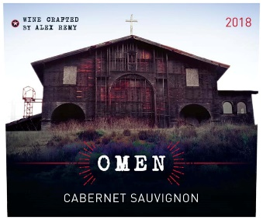**2018 Omen Cabernet Sauvignon $20.00  
Tasting Notes**: From blackberry to cassis and cedar, the complexity of the blend transcends into subtle notes of leather and dark chocolate. The mouthfeel is rich with luscious and elegant tannins. A very bold and powerful wine that is still approachable and balanced. Ample fruit flavors and a good, firm texture give this medium-bodied wine the right varietal framework.  
**AVA**: 62% Paso Robles – 38% Sierra Foothills **Grapes**: 92% Cabernet Sauvignon, 5% Syrah, 3% Petite Sirah.   
NOTES:



[www.goodlifeguy.com](http://www.goodlifeguy.com) – KNSS98.7/1330 – Saturday’s Noon-1:00 p.m. Central