**Good Life Guy’s Wagner Family Virtual Wine Tasting Guide – June 27, 2020**

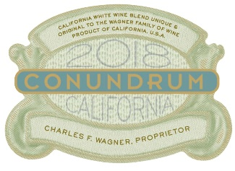Blending wines was almost unthinkable when **Conundrum White** was born in 1989, launching a trend that continues to this day. With a loyal and ever-growing following, this wine remains as inventive as ever. While the exact blend is under wraps, every vintage includes Chardonnay, Sauvignon Blanc, Semillon, Muscat Canelli, and Viognier. Conundrum White is amazingly versatile, with intriguing tropical notes and natural acidity. Best served chilled.  
NOTES:

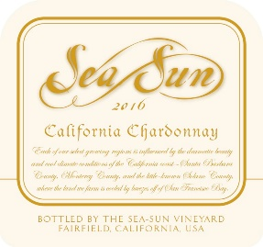

**Sea Sun Chardonnay** whose character speaks to the unique terrain where it is sourced in premier coastal regions of California. These vineyard sites span several hundred miles and feature subtle differences. The result is a wine featuring the best characteristics of Chardonnay, with fruit flavors, oak and acidity in harmony and balance.  
NOTES:

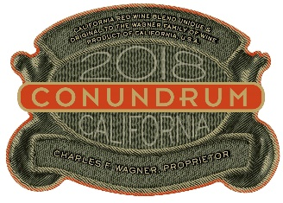Sourced from premier California winegrowing regions, **Conundrum Red** features dark red varietals including Petite Sirah, Zinfandel and Cabernet Sauvignon. It is rich, complex and approachable. With lush flavors of cherries and baking chocolate, this wine has fine tannins that create a silky smoothness. Be daring and drink Conundrum Red chilled to enhance its fruit profile and enjoy it any time of year.  
NOTES:

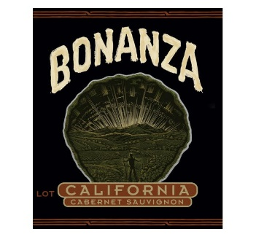

A California Cabernet Sauvignon, **Bonanza Cabernet** is produced by Chuck Wagner, owner and winemaker of Caymus Vineyards. It reflects the “bonanza” of the great state of California – the discovery of land where delicious Cabernet can be farmed. Calling back to a time when good wine with dinner was a simple pleasure, Bonanza features flavors of dark berries, vanilla and toasty bread with silky tannins.  
NOTES:

The Good Life radio show on KNSS 98.7/1330 KNSS Noon-1:00 p.m. CDT [**www.goodlifeguy.com**](http://www.goodlifeguy.com)