**DeLoach Vineyards** **Virtual Wine Tasting with Good Life Guy  
Saturday June 20, 6:00 p.m. CDT** **on Facebook LIVE - Great Value & Big Mail-in rebate!**

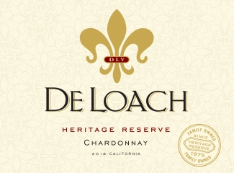This beautiful **Chardonnay** opens with floral aromas of orange blossom, Bartlett pear and notes of vanilla. Crisp flavors of green apple, nectarine and mango coat the palate with great minerality that is reminiscent of the finest California Chardonnays. Soft and creamy, this wine lingers and highlights the flavors of steamed fish & spring vegetables. ABV14.5%  
NOTES:

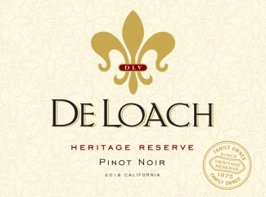This **Pinot Noir** opens with a bouquet of red fruit aromas including cherry, cranberry and strawberry. Juicy red fruit flavors are complemented by a touch of spice and hint of tobacco. Medium in body, this is a well-balanced wine with an elegant finish and pairs nicely with a variety of lighter dishes. ABV13.5%  
NOTES:

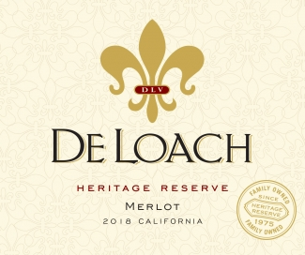This **Merlot** opens with lively aromas of black plum, blackberry and cherries with a touch of cocoa. Rich flavors of strawberry jam, graham cracker and caramel are complemented by undertones of a toasty vanilla oak. This is a fruit forward wine with a lush mouthfeel and long finish. It is a perfect pairing to barbecued ribs or grilled pork chops. ABV14.5%  
NOTES:

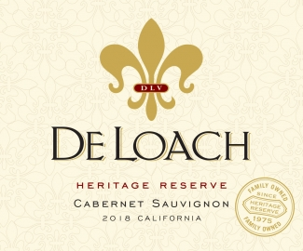This **Cabernet** opens with fragrant aromas of dark cherry, blackberry and rich cedar notes with a touch of nutmeg on the nose. Ripe raspberry, baked blueberry pie, plum and mocha flavors coat the palate in this well-balanced wine that is made in a ready to drink style. Moderate acidity is matched by fine tannins and a long, satisfying finish. ABV13.5%  
NOTES:

  
The Good Life radio show on KNSS 98.7/1330 KNSS Noon-1:00 p.m. CDT **www.goodlifeguy.com**